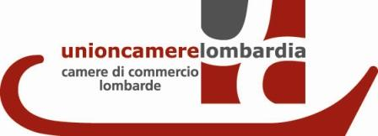
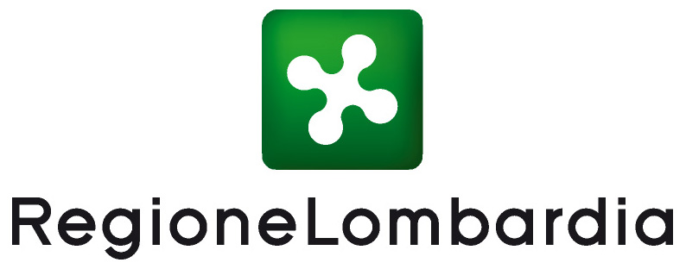

Innovating the Land:
the Lombardy Region of Italy Dialogues with the World at EXPO2015

The National Research Council of Italy (CNR), the Lombardy Regional Government and Unioncamere Lombardia (the Lombardy Chambers of Commerce network), have together created a series of events, named the Lombardy Dialogues, that will describe research and innovation activities developed in relation to the region’s environmental resources and food products, with the purpose of promoting a dialogue with the international community.

Stemmed from the Framework Agreement signed between the National Research Council of Italy and the Lombardy Regional Government, in partnership with Unioncamere Lombardia, the Lombardy Dialogues consist of three engaging events that find their thematic inspiration in several features of the Lombardy food sector and cultivated land. Under the scope of the project “Exhibition Ground for Scientific Research: Italian Pavillon for EXPO2015" the Lombardy Dialogues tell how scientific innovations, developed in Lombardy, support intensive and sustainable productions, protect traditional products and manage environmental resources. The goal is to foster a dialogue between the research that is carried out regionally and the worldwide community. The events will be presented as a series of short lectures and dialogues, each culminating in a thematic thread connected to one of the month-long themes scheduled by the Italian Pavilion.

“Lombardy Dialogues” will debut on the 5th of May - the month that the Italian Pavillon has dedicated to Food Security - with the first dialogue entitled "Food Safurity: Bridging Safety and Security" that will be held at the Auditorium Testori, Palazzo Lombardia, Milan. Starting from fundamental Lombardy productions such as milk, meat and cereals, the conference will focus on food processing systems, traceability, packaging and logistics, within the framework of food security.
The goal of the conference is to outline the new concept of "food global quality" for the food industry of the future.

The second event "Setting a Model for a Sustainable Dairy Chain" will be held at the Auditorium of Italian Pavillon EXPO Area, Milan, on the 22th of July (the month dedicated to Sustainability and Biodiversity). The event focuses on different factors affecting dairy-chain sustainability, such as animal wellbeing and diet, milk composition and processing, sewage and slaughtering waste recycled for fertilizer and energy production. The Lombardy framework is proposed as a paradigm of best practices for promoting and protecting traditional agricultural productions worldwide.

On the 27th of October (the month devoted to Technological Innovations) at the Auditorium Testori, Palazzo Lombardia, Milan, the dialogue "Innovative Monitoring and Management of Environmental Resources" will focus on several innovative tools and approaches designed to manage, monitor and preserve Lombardy environmental resources. Soil, water, intensive and traditional crop farming, agri-food waste management for the production of bioproducts and energy are all analyzed through the lens of a judicious balance between food production and environmental protection.

All three initiatives will engage recognized international experts, and will bring together practitioners, stakeholders, researchers and end-users who are involved in the selected thematic area.

